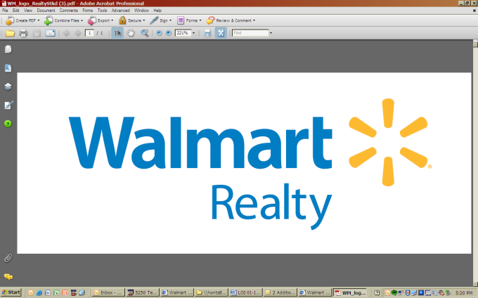 | 2608 SE J Street  Bentonville, AR 72716-5535  walmartrealty.com

Purchaser’s Letter of Intent
Building SALE or dropped project sale

PLEASE REDLINE THIS LOI AND E-MAIL TO THE LISTING WALMART MANAGER OR BROKER

Date: Property Location (City, State, WM Store #):

The following proposal establishes the basic terms and conditions Purchaser desires to submit to the Walmart Realty Committee for review in connection with the purchase of land at the above-referenced location. The terms herein are NOT to be considered an offer of any kind by and are non-binding on Walmart, its affiliates, employees or agents, and are subject to change. Any transaction is subject to Walmart Realty Committee approval and the parties’ subsequent execution of a mutually acceptable Agreement of Sale (“AOS”), to be prepared by Walmart Realty, if approved by the Walmart Realty Committee.

- Premises: Approximately square feet of building area and __________acres, known as Parcel #(s) __________ in the location generally depicted on the site plan attached hereto as Exhibit A (hereinafter referred to as the “Property”).

- Condition: “As is where is” with no representations or warranties.

- Mineral Rights: Seller shall retain any and all subsurface mineral rights.

- Seller: Walmart Inc. or other Walmart affiliate.

- Purchaser (execution of AOS): Purchaser Attorney (send the AOS to):
Entity: Entity:
Phys Address: Phys Address:
City, State, Zip: City, State, Zip:
Contact: Contact:
Phone: Phone:
Email: Email:

- Purchase Price: $___________________

- Escrow Deposit: Eight percent (8%) of the final negotiated Purchase Price, in cash and due upon mutual execution of the AOS, which becomes non-refundable at the end of the “Due Diligence Period”, as hereinafter defined.

- ALTA Survey of Property: Obtained by Purchaser at its sole cost and expense. Said survey shall be certified to Purchaser, Seller, and Title Company.

- Title Insurance: Seller shall determine which Title Company will be used for this transaction. Title commitment is ordered by Seller. Purchaser responsible costs of title policy and any additional or extended coverage.

- Transfer, Sales Taxes, Closing Costs & Fees: To be paid by Purchaser (property taxes will be pro-rated at closing).

- Due Diligence Period: ________ days after full execution of the AOS, provided the AOS is executed within forty-five (45) days after Walmart Realty Committee approval. Time is of the essence. Purchaser shall begin due diligence investigations immediately upon execution of the AOS.

During the Due Diligence Period, Purchaser will perform a survey, conduct engineering studies, title examination(s) and such other inspections and examinations as Purchaser deems necessary and/or appropriate and submit copies thereof to Seller. If, during the Due Diligence Period, the survey discloses a condition rendering the property unusable, or if the results of analyses, test borings, or other studies disclose that the physical condition of the Property, including the existence of hazardous wastes and toxic substances, will prevent Purchaser from reasonably developing the Property for the intended use, Purchaser shall have the right to terminate the AOS and have the Escrow Deposit refunded. Any other termination of the AOS shall result in Purchaser’s forfeiture of Escrow Deposit.

Permit Period: _________ days after expiration of Due Diligence Period. If, during the Permit Period, Purchaser is unable to obtain all of the necessary permits and governmental approvals required for Purchaser’s proposed development, Purchaser shall have the right to terminate the AOS and have the Escrow Deposit refunded. Any other termination of the AOS shall result in Purchaser’s forfeiture of Escrow Deposit.

- Closing: To occur no later than 30 days after the expiration of the Permit Period.

- Noxious Use Deed Restrictions.

Property shall not be used for or in support of the following:

(i) adult book store, adult video store (an adult video store is a video store that sells or rents videos that are rated NC-17, X, XX, XXX, or of a rating assigned to works containing material more sexually explicit than XXX, by the film rating board of the Classification and Rating Administration), “adult” business activities, including without limitation any massage parlor, escort service, facility with nude (or partially nude, bathing suit-clad or lingerie-clad) models or dancers or any establishment selling or exhibiting sexually explicit materials;

(ii) pawn shop, bar, night club, gaming activities (including but not limited to gambling, electronic gaming machines, slot machines and other devices similar to the aforementioned);

(iii) any business that cashes checks or makes short-term or “payday advance” type loans (but not excluding the regular business of any bank or financial institution insured by F.D.IC. or mortgage brokerage firm or other similar business providing long-term, mortgage type loans);

(iv) any business or facility used in growing, delivering, transferring, supplying, dispensing, dispersing, distributing or selling marijuana or any synthetic substance containing tetrahydrocannabinol, any psychoactive metabolite thereof, or any substance chemically similar to any of the foregoing, whether by prescription, medical recommendation or otherwise, and whether consisting of live plants, seeds, seedlings or processed or harvested portions of the marijuana plant; or

(v) involuntary human detention or incarceration (collectively, the “Noxious Use Restrictions”).

the Noxious Use Restrictions shall be perpetual unless applicable law prohibits a perpetual restriction, in which case the Noxious Use Restrictions shall remain in effect for the maximum amount of time allowed by law but in no event fewer than one hundred (100) years.

- Proposed Use(s)/User(s):

- Commission: If applicable, Seller shall pay a brokerage commission to the cooperating third party broker (who does not have any ownership interest in the Purchaser’s entity or the Property at or before Closing) on the transaction per the terms of the broker registration agreement that must be signed and submitted with all offers. All other brokerage and representation fees (other than Seller’s broker) shall be the sole responsibility of the Purchaser. If a cooperating broker is involved in the transaction, please list info below and submit a signed cooperating brokerage agreement with this LOI:
Entity:
Phys Address:
City, State, Zip:
Contact:
Phone:
Email:

Walmart Broker:
Entity:
Phys Address:
City, State, Zip:
Contact:
Phone:
Email:

- There shall be no binding agreement between Seller and Purchaser until such time as a mutually acceptable agreement of sale has been executed by both Purchaser and Walmart.

Signature of Purchaser: _____________________________ Date: ___________________

